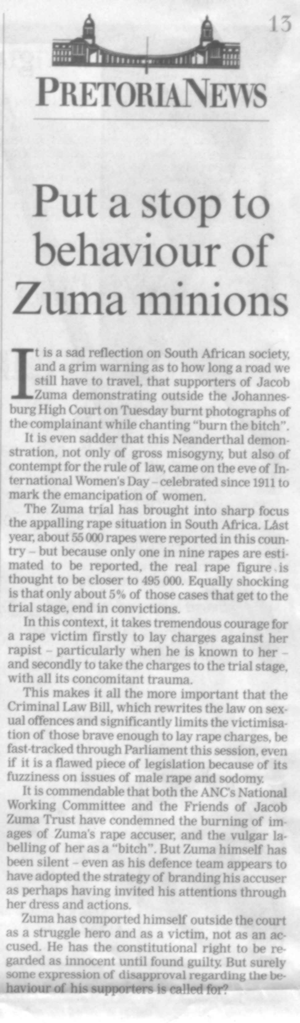

Extract from the Pretoria News of 9 March 2006.
